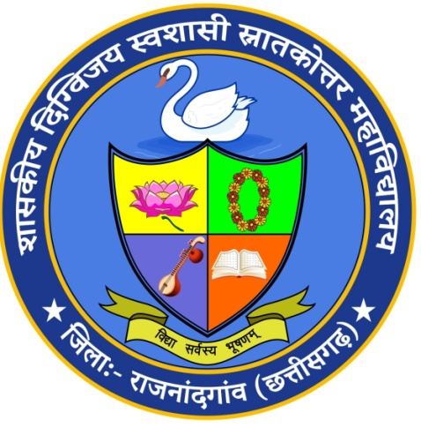

**Department of English**

The first activity for the session 2024-25 was Board of studies meeting on 11/05/24. The agenda of this meeting was to review and redesign the syllabus of UG 3rd , 4th , 5th and 6th semester as per LOCF and syllabus of PG as per National Education Policy 2020. For UG 1st and 2nd semester syllabus, prepared by the Central Board of Studies , was implemented from session 2024-25. The expert members were Dr. Anita Shankar, Chairperson; Dr. Rashmi Dubey, VC nominee; Dr. Rabinder Chhabra, Principal Nominee; Dr. Shiny Mendos, Principle Nominee; Mr Darshan Bajaj, Industrial Member.

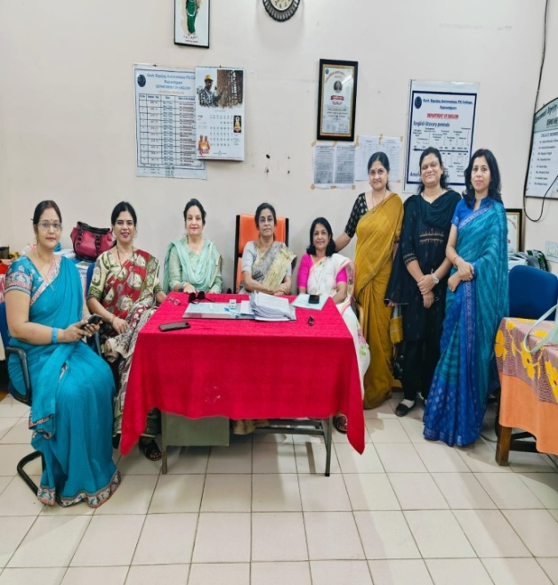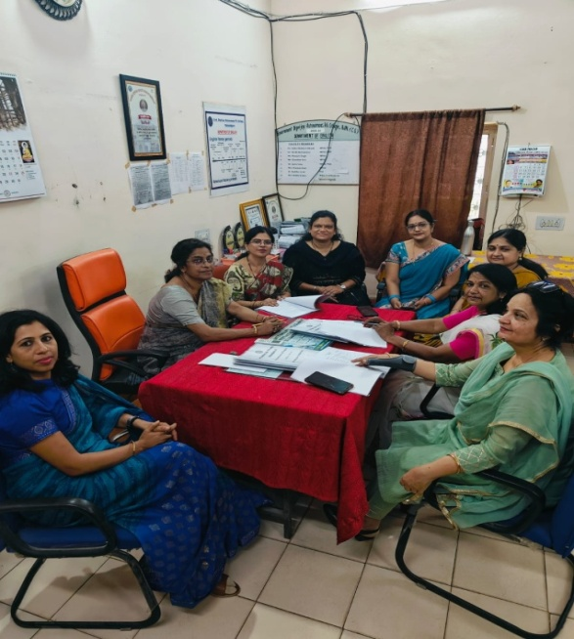

The birthday celebration of Harry Potter was organised on 31/07/2024. The day was celebrated by introducing Harry Potter’s life through speech, quiz and a skit. The skit was performed by MA I & III semester students.

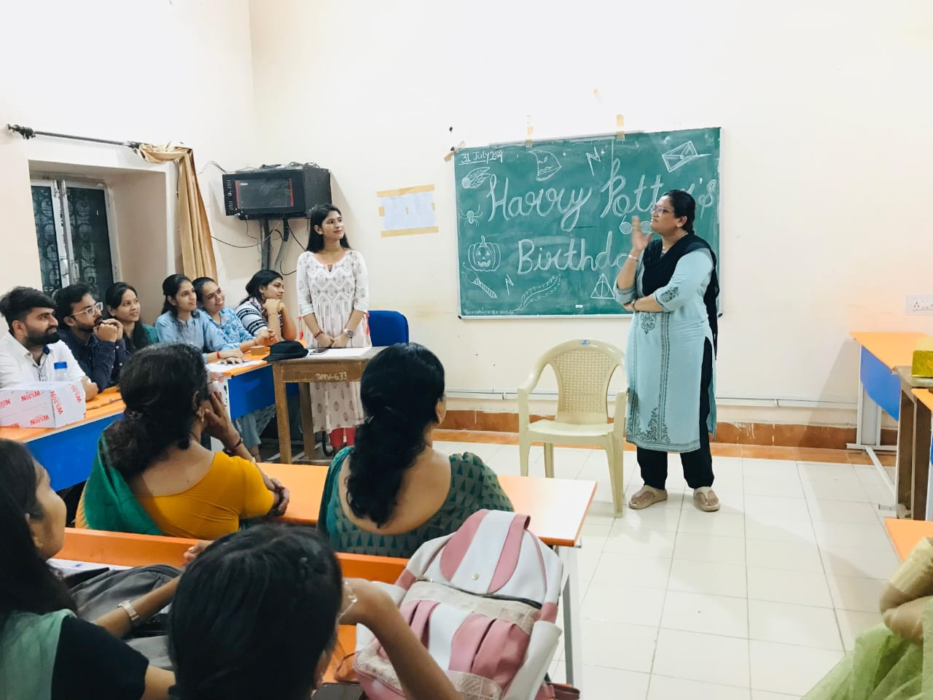

Plantation activity was organised on 12/08/24, students were directed to bring medicinal plants and ornamental plants such as Brahmi, Lemongrass, Mint, Aprajita, etc, for the activity.

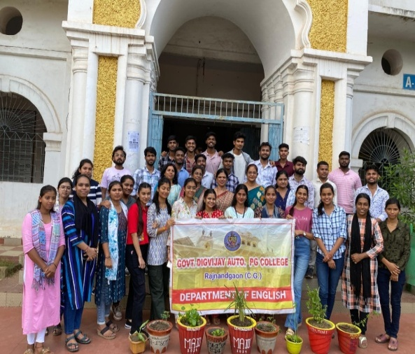 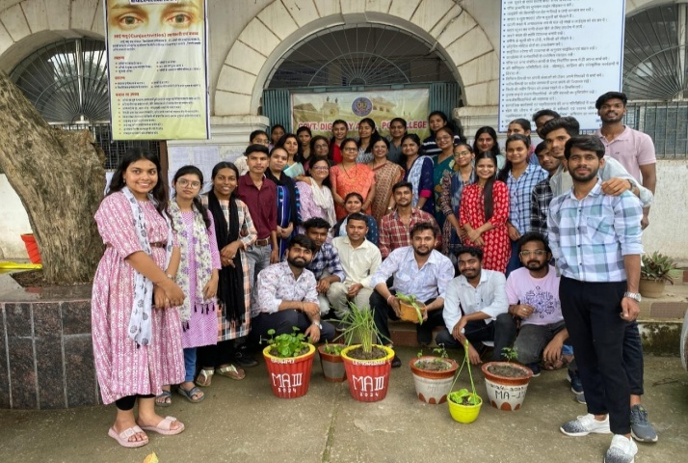

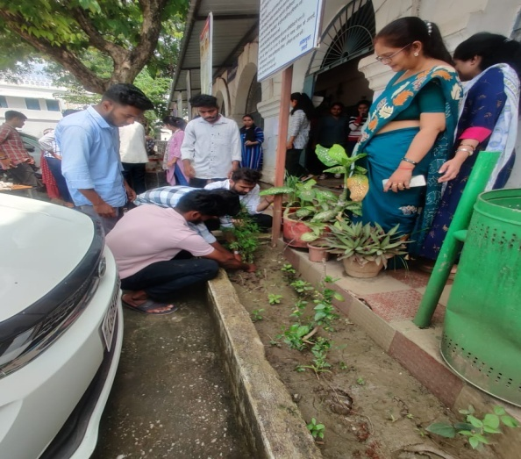 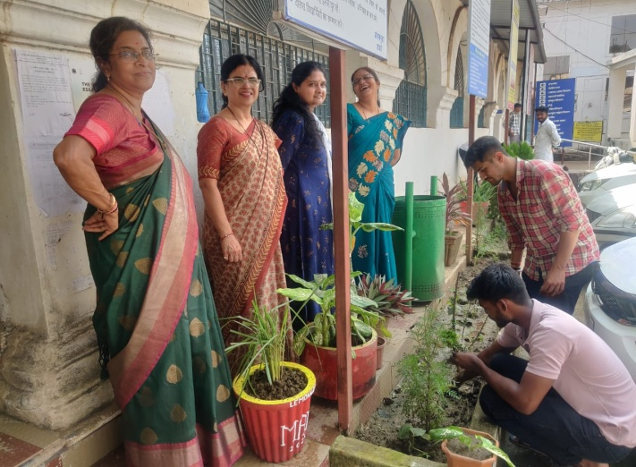

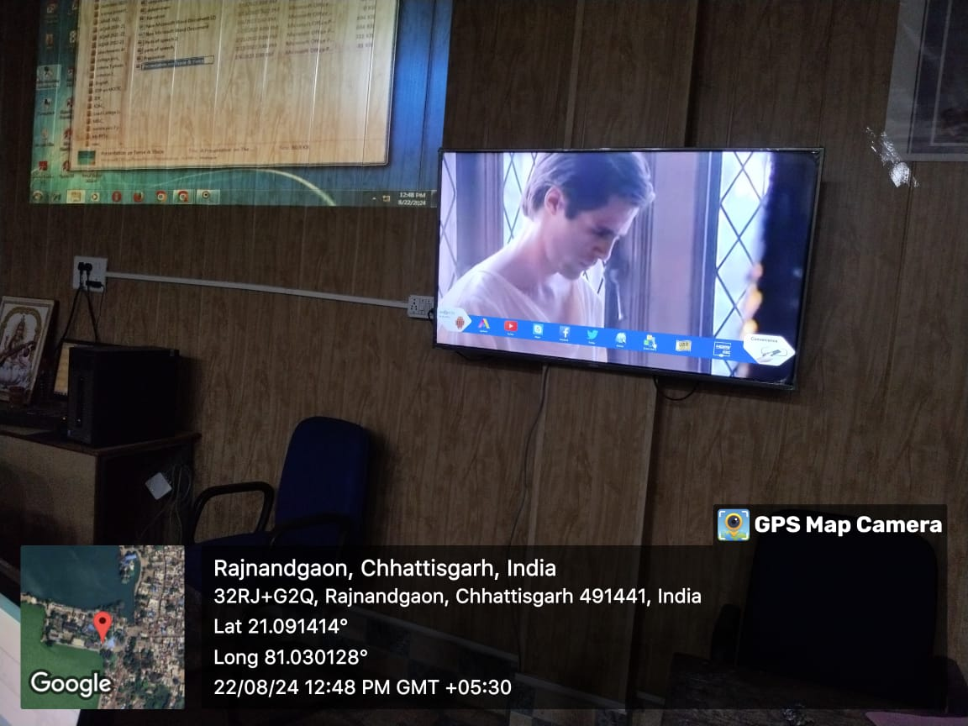On 22/08/24, ‘Chew & View’ activity was organised. In this activity movie Hamlet, which is based on Shakespeare’s drama was shown. The purpose of the activity was to foster reading as well as discussion skills in students.

On 31/08/24, the department of English organised the inaugural function of literary association in which the students were nominated as office bearers; President, Vice President, Secretary, Joint Secretary and Treasurer. On this occasion ‘**One Day Workshop on NET and SET examination**’ was organised for the students of PG under MoU activity. The invited Guest Speaker on the occasion was Miss Punyaprada Singh, Assistant Professor in English, Shivnath Science College, Rajnandgaon. She delivered a very beneficial lecture to the students.

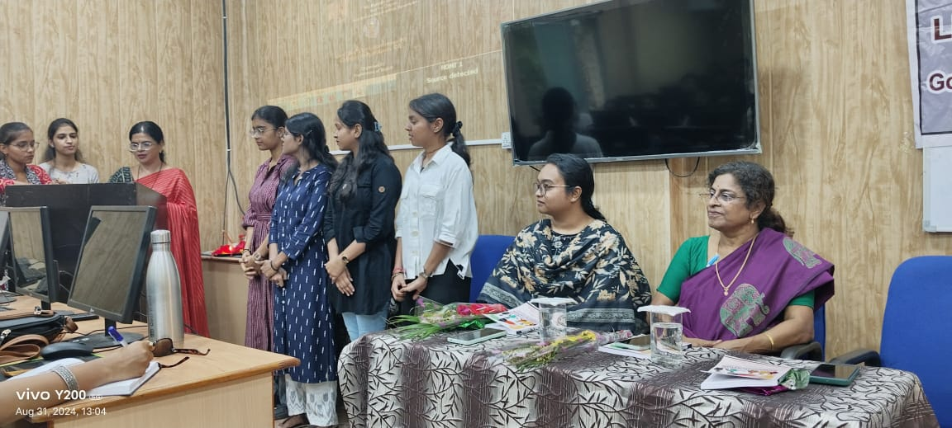

The Teacher’s day Programme was celebrated by the students of English Literature from PG and UG classes on 09/09/24. They honoured all the teachers by giving bouquets and name plates with photograph of the teachers as a token of love and respect. They shared their thoughts about their favourite teacher. They celebrated this day by giving a tribute to Kolkata Rape Case victim by performing a skit and also discussed ways to protect our girls and eradicate such criminal acts from the society.

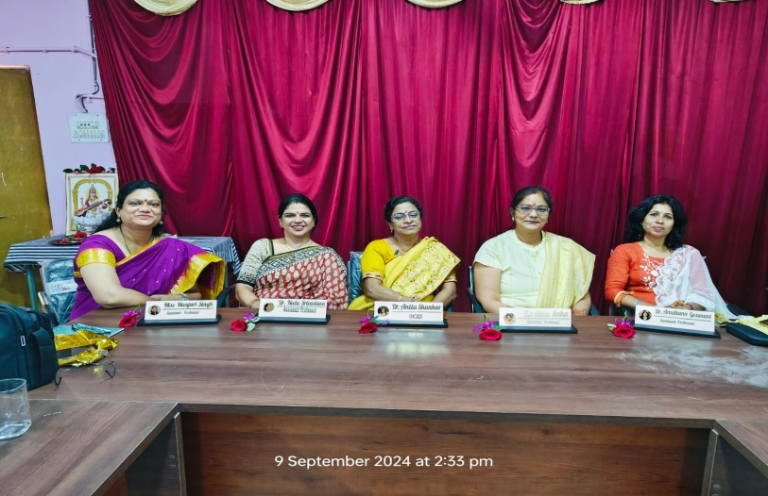

A Debate competition had been organised on ‘The Denizen of C.G have been benefitted by the welfare schemes of the state government during last year: Favour & Against’ by the department on 19/11/24. It was an open competition for students of all the departments. Many students, from various streams, took part in the competition. Dr Neelu Shrivastava, Dr Anita Saha and Dr Neelam Tiwari were present as judges.

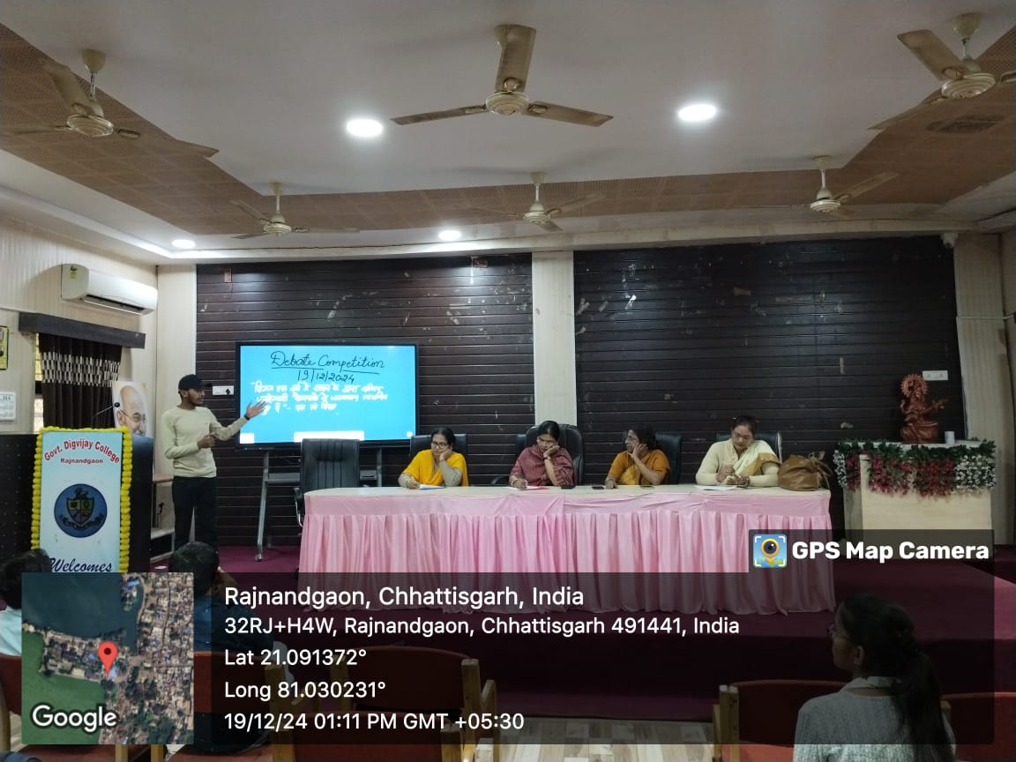

The alumni meet was organized by the department on 22/11/2024. Our alumni, who are posted at different places and organizations at prestigious positions, were invited in the department.

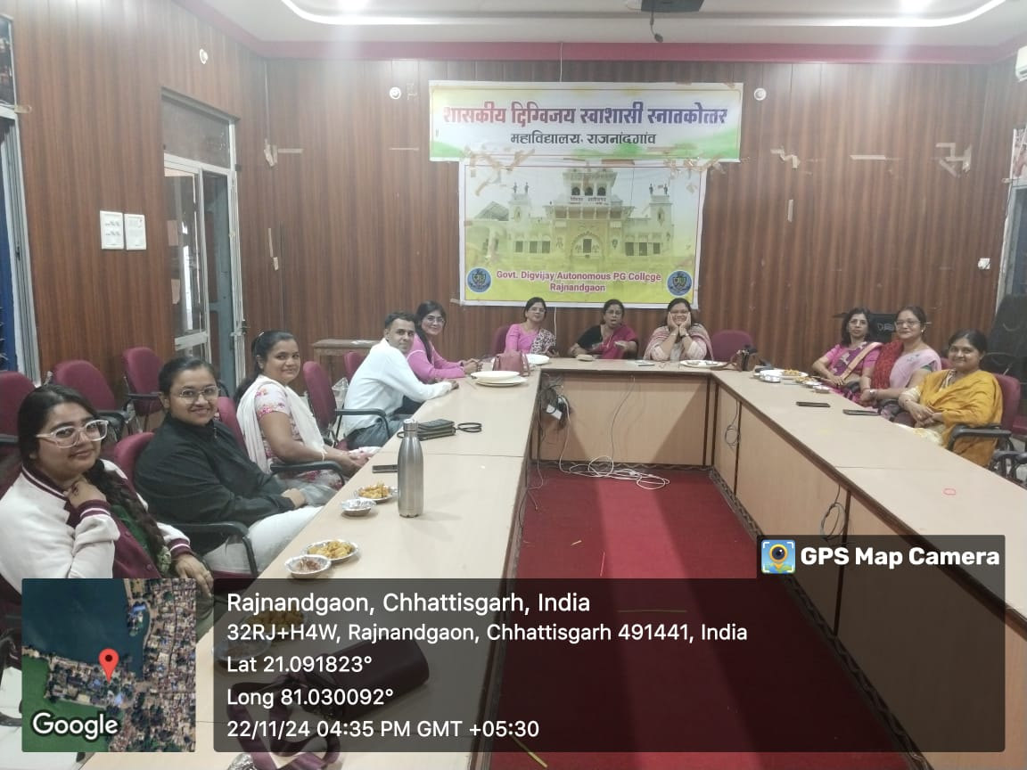

A guest lecture was organised in the department on ‘Career Opportunities in the Field of English language & Literature’ on 22/12/2024. The resource person was Shri Subhash Chandra Goswami, retired senior lecturer in English, Bengali Tata Inter College, Varanasi, Uttar Pradesh. Goswami sir said that the students can try their career as writers publishers, teachers, professors, journalists, media persons, in advertisements, and so on. The students raised their queries and sir satisfied them with his valuable answers.

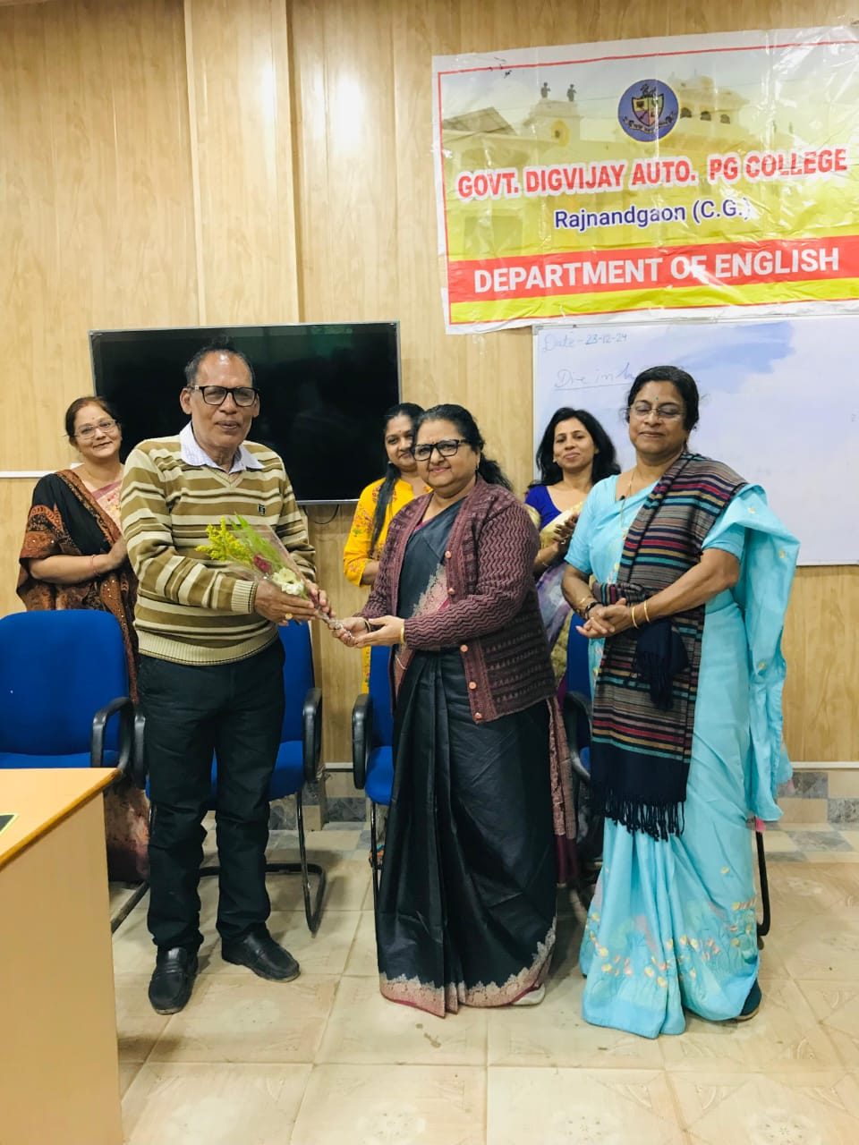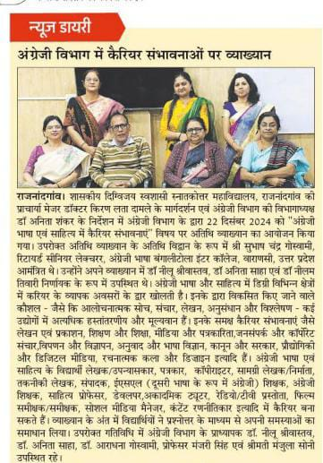

The department of English organised an Extension Activity on 09/01/25. As per the instructions received from the Department of Higher Education. The department of English visited PM Shri Sarveshwar Das NPN School of Excellence, Rajnandgaon, under Poshak Vidyalaya Sampark Abhiyan as ‘Agrani Digvijay’ for extension activity. The objective of the extension activity was to provide information to students of class XI and XII regarding Courses available for their Undergraduate courses in Government Digvijay College, Rajnandgaon, so that they can have an idea of the available courses and can easily opt the subjects for different courses.

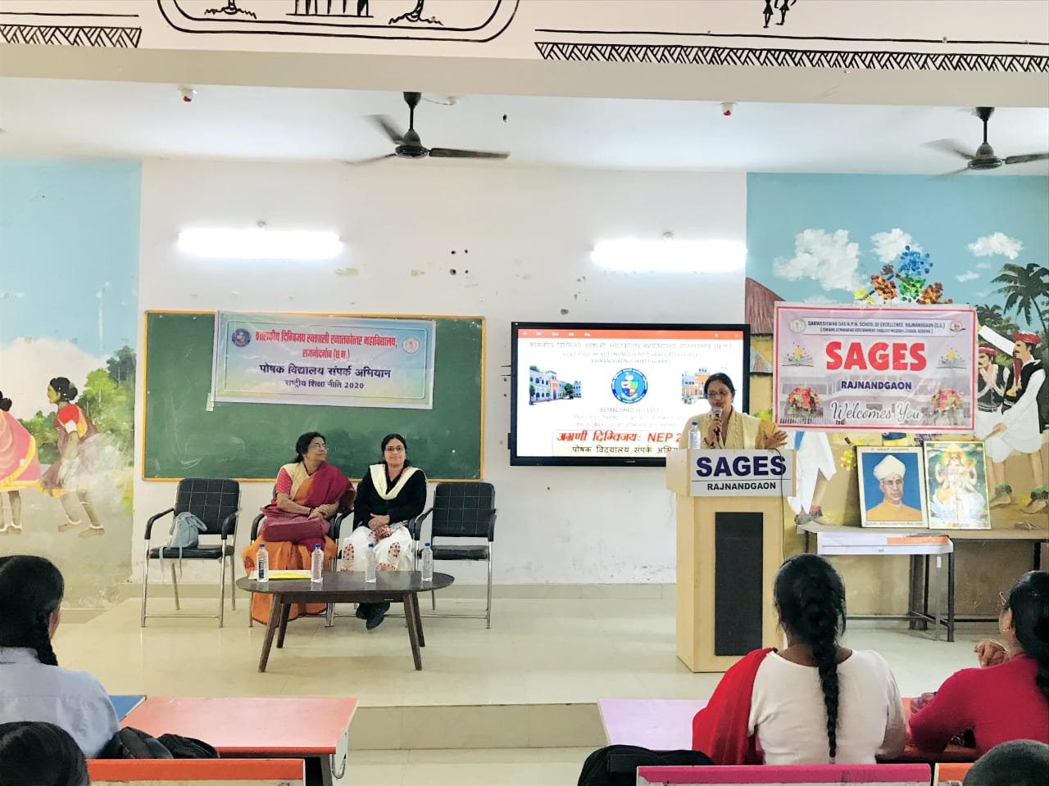

Under PM USHA (Pradhan Mantra Uchhatar Siksha Abhiyan), Component V : Gender Inclusion and Equity Initiatives, 2023-26, the department of English organised a five day workshop on ‘Communication Skills’ from 03/02/25 to 07/02/25 for girl students. In five days students got the opportunity to learn various ways to enhance their speaking as well as writing skills. The resource persons for the five days were Miss Punyaprada Singh, Assistant Professor, Govt. Shivnath Science College, Rajnandgaon; Dr. Ravi Shanker Panicker, Principal, BIT Degree College, Raipur; Dr. Neelu Shrivastava, Assistant Professor, Govt Digvijay College, Rajnandgaon; Mrs Deepti Bindal, NLP Trainer Rajnandgaon ; and Mr Chandan Soni, Assistant Professor, Govt Lahiri PG College, Chirmiri, respectively.

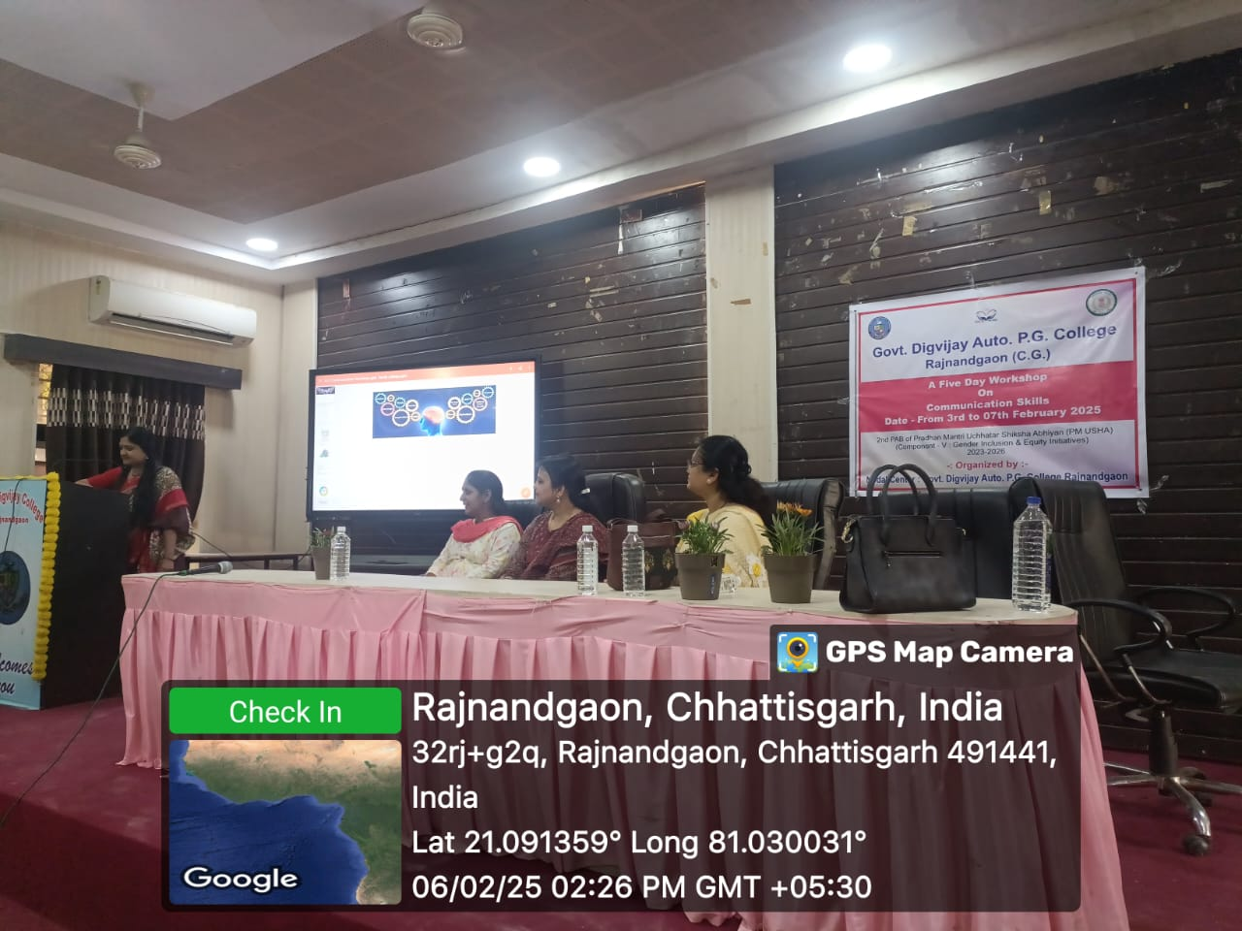

Three day international conference on ‘Indian Literature in Global Perspective: Significance and Relevance’ was organised by the department in collaboration with Hindi and Sanskrit departments from 13/02/25 to 15/02/25. In the inauguration ceremony Prof. Dr R Shridhar, honourable Vice Chancellor, Kalinga University, Naya Raipur graced the session as the chief guest. The keynote speakers for three days were Dr Shriram Parihar, renowned literary personality from Khandawa, Madhya Pradesh; Dr. I. D Tiwari, former Registrar; Dr Gopal Ashque, member of the Language Commission, Kathmandu, Nepal; Dr. Litton Baron Sikder, Associate Professor, Islamia University, Bangladesh; Dr. Purnima Kelkar, Associate Professor, Indra Kala Sangeet Vishwavidyalaya, Khairagarh had present physically in the conference; and Dr Nupur Ashok poetess from Austrakia and Dr. S.Chitra from Bhutan were joined virtually. In three days international conference five technical sessions were conducted which was chaired by respective above mention guests. On second day, a cultural programme had been organised by the organising committee in the honour of the guests from the country and abroad. The valedictory session was presided by Dr. Pukhraj Bafna, Padmashri; and Dr Tarlochan Kaur, Assistant Professor, Govt. VYT PG Autonomous College, Durg. At the end of the conference the vote of thanks was proposed by Dr. Neelu Shrivastava.

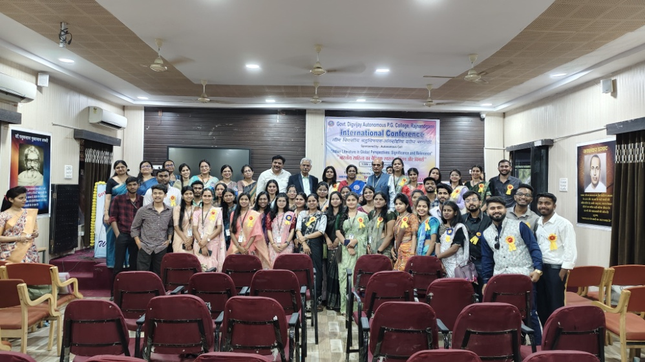

The department of English celebrated the International Women’s day under the theme of ‘English Literature of all Times’ on 11/03/25. The office bearer of the Literary Association made all the arrangements under the guidance of the faculty members. Through power point presentation, the students presented the life and works of great women writers of English Literature. The students, Medhashri, Megha Jain, Princy Hariharno and Puri Bagde recited their own poems. A dance on the theme of women empowerment was performed by the students. The programme was ended with cake cutting ceremony.

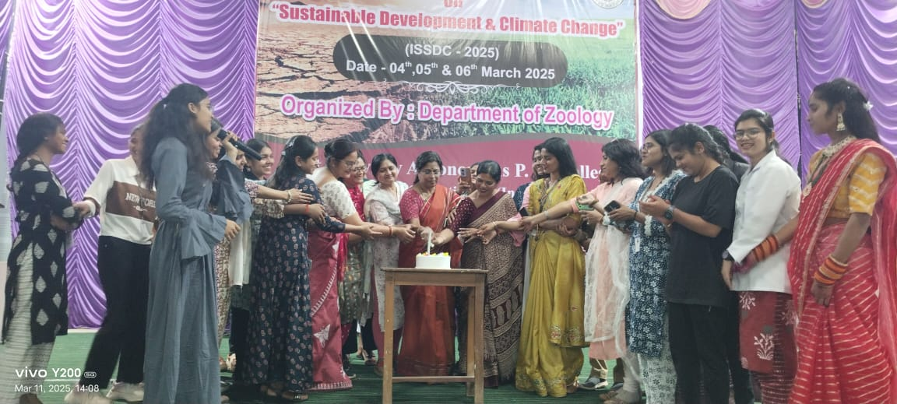

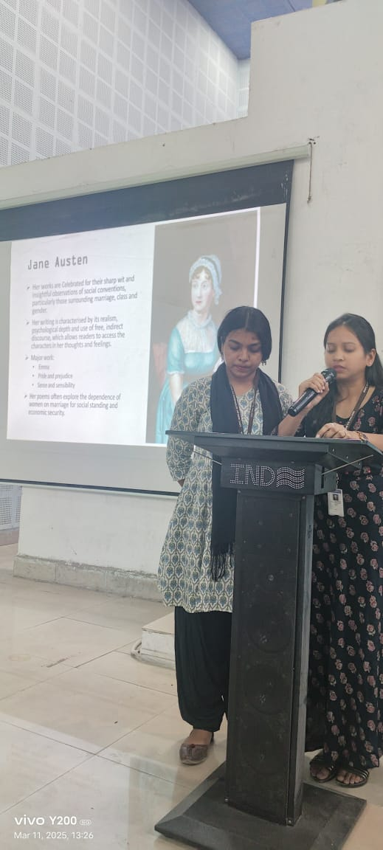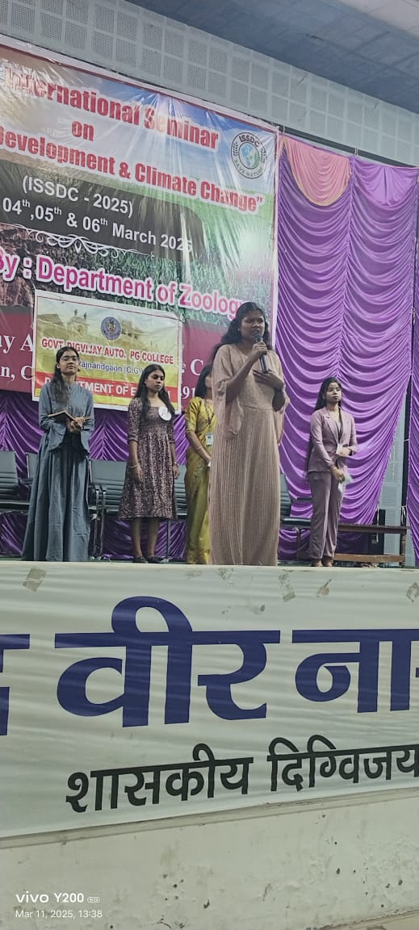

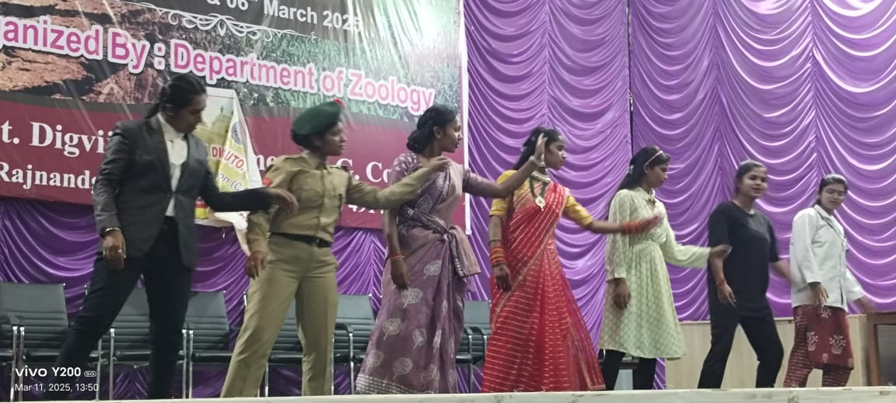’

-----------------------X----------------